www.highonthehogfestival.com
Trail Run  March 4  BBQ Contest  April 21 – 22  2017 | 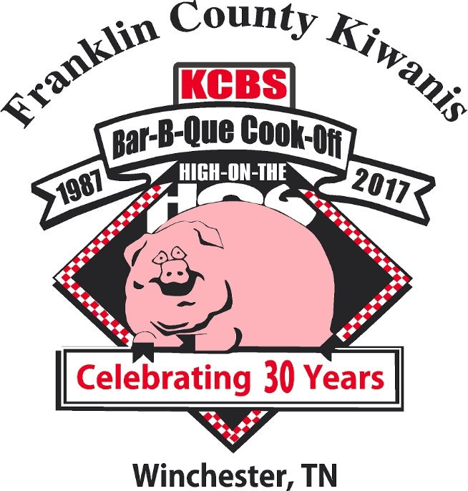

The Kiwanis Club of Franklin County is proud to present the 30th Annual High on the Hog Festival & KCBS BBQ Contest located in the Winchester Tennessee City Park by the scenic Tim’s Ford Lake.

MAJOR COMMUNITY PARTNER

$1000.00 Minimum

*Your Company Name listed with Major Sponsors in commercial to be aired on Social Media, Web Site and on local selected TV month prior to festival
*Company Logo on banner at Trail Run & Festival
* Your sponsor signs along path of Trail Run
* 4 Inch Logo on the event t shirt
*Ad (Quarter page) in Tabloid in total circulation of Herald Chronicle
*Logo on festival web site with link to your web site
*Listed in Thank You ad in tabloid
*Ten tickets for Sponsors BBQ dinner

SILVER COMMUNITY PARTNER
$500.00 Minimum
*Company name on banner at Trail Run & Festival
* 3 Inch logo on event tee shirt
*Ad (1 X 5 column) in tabloid in total circulation of Herald Chronicle
*Listed on Web site
*Listed in thank you ad in tabloid
*Six tickets for Sponsors BBQ Dinner

BRONZE COMMUNITY PARTNER
*$250.00 Minimum
*Company Name listed in thank you ad in tabloid
* 2 Inch logo on event tee shirt
*Listed on web site
*Four tickets to Sponsors BBQ Dinner

TRAIL RUN COMMUNITY PARTNER
$100.00 Minimum
*Listed in thank you ad in tabloid
*2 tickets to Sponsors BBQ Dinner

TRAIL RUN FRIENDS
$25.00 Minimum
* 18 X 24 inch sign to be placed on the trail day of the event

